Lab 06 - Secure REST Services with Spring Boot using JSON Web Token (JWT)

1. Introduction
A JWT (JSON Web Token) is an open standard (RFC 7519) used for securely transmitting information between two parties (such as a client and a server) in the form of a JSON object. It is widely used in authentication and authorization systems, particularly in modern web applications.
A JWT is typically composed of three parts:
- Header: Contains metadata about the token, such as the signing algorithm.
- Payload: Contains the claims (information) that are being transmitted. These claims can be registered, public, or private.
- Signature: Ensures the integrity of the token and verifies that it was created by the intended issuer.
Imagine you're a new fresher Spring Boot developer of IT Department in a University. Your manager has asked you to develop a RESTful API with registration and login to Orchid Management.
The RESTful API has to support registration, login for an orchid - a standardized usage action verbs better known as Create, Read, Update, Delete (CRUD).
This lab explores creating a RESTful API using Spring Boot 3, JWT with Data Source is MS SQL Server. An SQL Server Database will be created to persist the user information by Spring Data JPA

2. Lab Objectives
In this lab, you will:
- Use the Intellij IDEA to create Spring Initializr Project (Maybe you can create the Spring Initializr project in https://start.spring.io/ then open this project in IntelliJ IDEA).
- Choose Spring Web for Building web, including RESTful, applications using Spring MVC. Uses Apache Tomcat as the default embedded container. Spring Data JPA SQL for persisting data in SQL stores with Java Persistence API using Spring Data and Hibernate. MS SQL Server Driver SQL - A JDBC and R2DBC driver that provides access to Microsoft SQL Server and Azure SQL Database from any Java application.
- Use in SQL Server Database as a Data Source
- Develop 3-Layer with Repository Architecture to perform registration and login actions using Spring RESTful API with JWT.
- Run the project and test the application actions.

Activity 01: Design the Registration and Login with JWT

Step 01. Open IntelliJ IDEA, File | New | Initializr Project
In the left pane of the New Project wizard, select Spring Initializr Project.
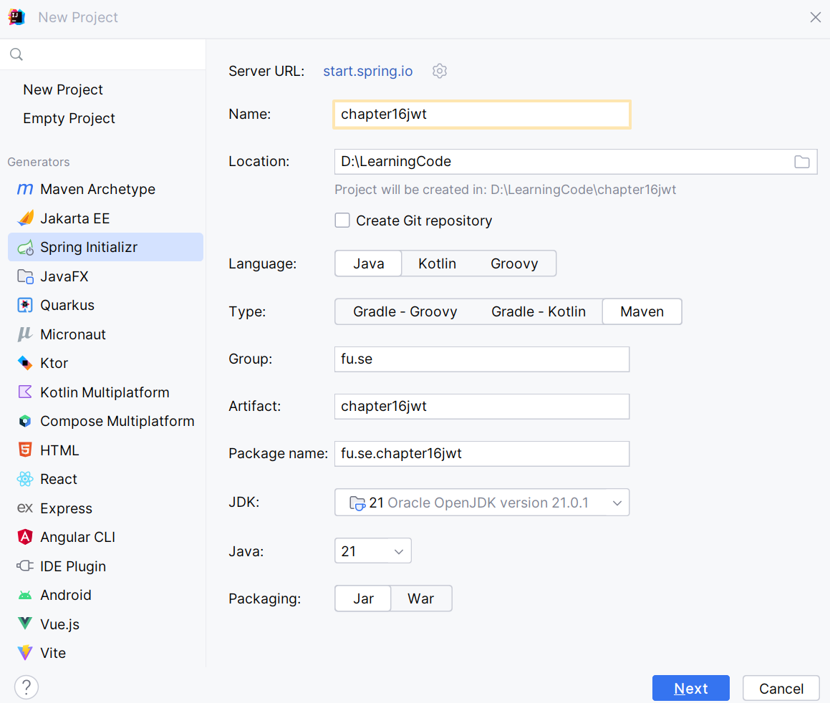

Step 02. Fill the information → Next

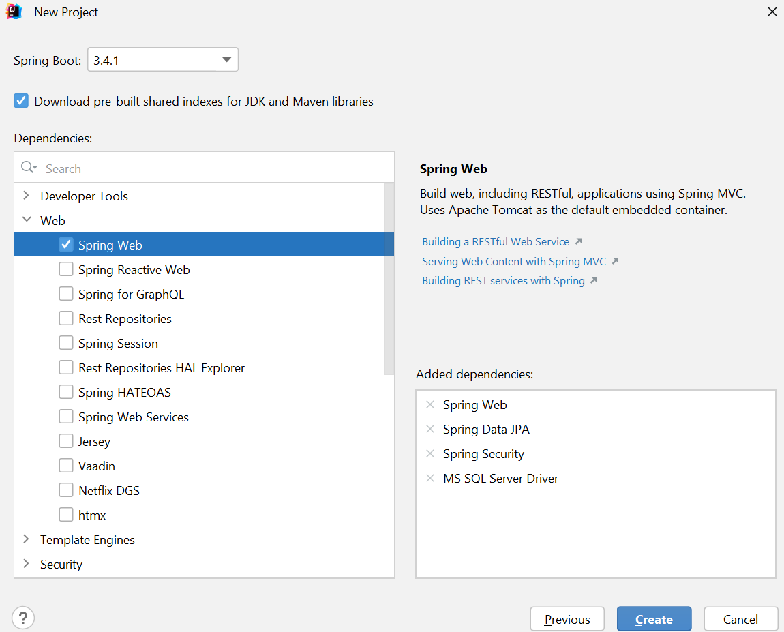
Step 03. Choose the dependency/dependencies → Click Create

Or you can using Spring Initializr project in https://start.spring.io/ then open this project in IntelliJ IDEA
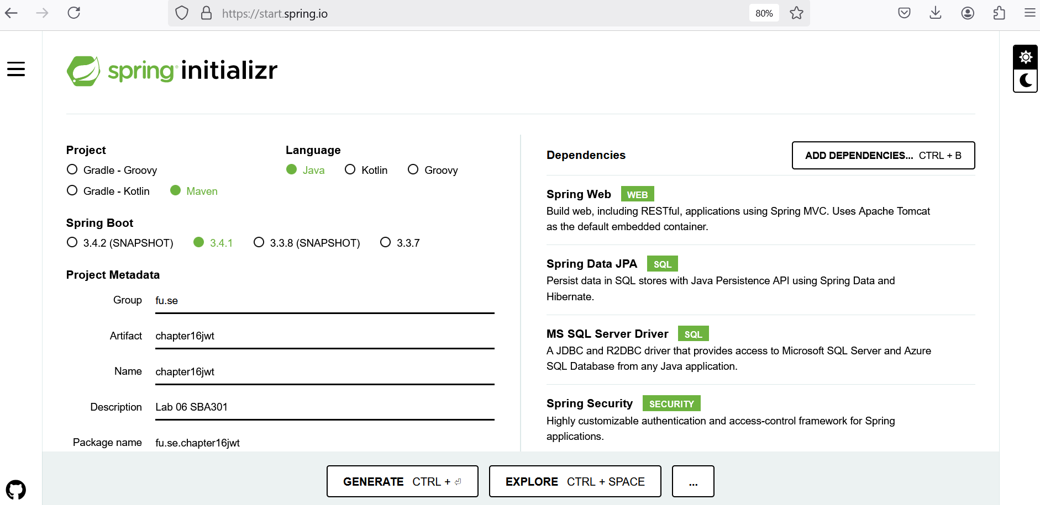

Step 04. Edit pom.xml, add the dependencies for
- MS SQL Server Driver mssql-jdbc
- Spring Web - RESTful API: spring-boot-starter-web
- Spring Data JPA for Paging and Sort data: spring-data-jpa
- Testing spring-boot-starter-test

<dependencies>
<dependency>
<groupId>org.springframework.boot</groupId>
<artifactId>spring-boot-starter-data-jpa</artifactId>
</dependency>
<dependency>
<groupId>org.springframework.boot</groupId>
<artifactId>spring-boot-starter-web</artifactId>
</dependency>
<dependency>
<groupId>com.microsoft.sqlserver</groupId>
<artifactId>mssql-jdbc</artifactId>
<scope>runtime</scope>
</dependency>
<dependency>
<groupId>org.springframework.security</groupId>
<artifactId>spring-security-test</artifactId>
<scope>test</scope>
</dependency>
<dependency>
<groupId>org.springframework.boot</groupId>
<artifactId>spring-boot-starter-test</artifactId>
<scope>test</scope>
</dependency>
</dependencies>

Add JWT dependecies
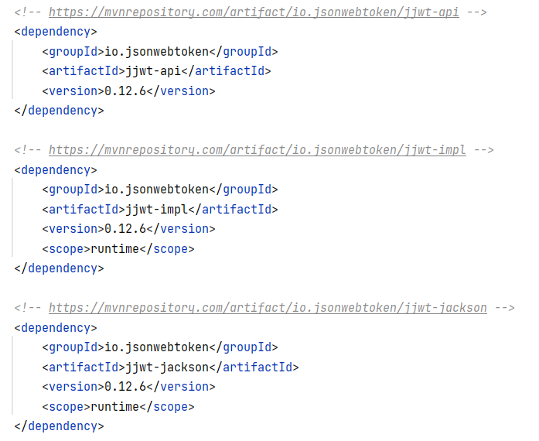

Step 05. The structure of the Lab project
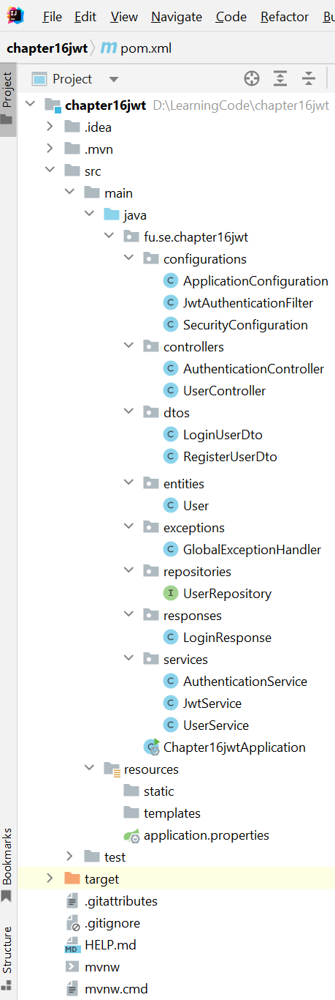

Step 06. The application.properties file
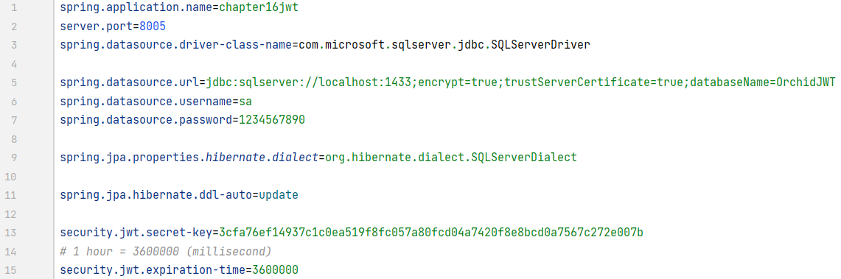

Activity 02: Implement RESTful API with JWT for registration and login functions

Step 01. Create entities package, then create User class
- Create the user entity. Then, extend the User Entity with authentication details.
- To manage user details related to authentication, Spring Security provides an interface named “UserDetails” with properties and methods that the User entity must override the implementation.
- The method “getAuthorities()” returns the user’s roles list; it is helpful to manage permissions.
- The method “getUsername()” returns the email address because it is unique information about the user.

Annotations:
- @Entity: Marks the class as a JPA entity
- @Id: Specifies the primary key field
- @GeneratedValue: Strategy for generating primary key values
- @Column: Maps a field to a database column
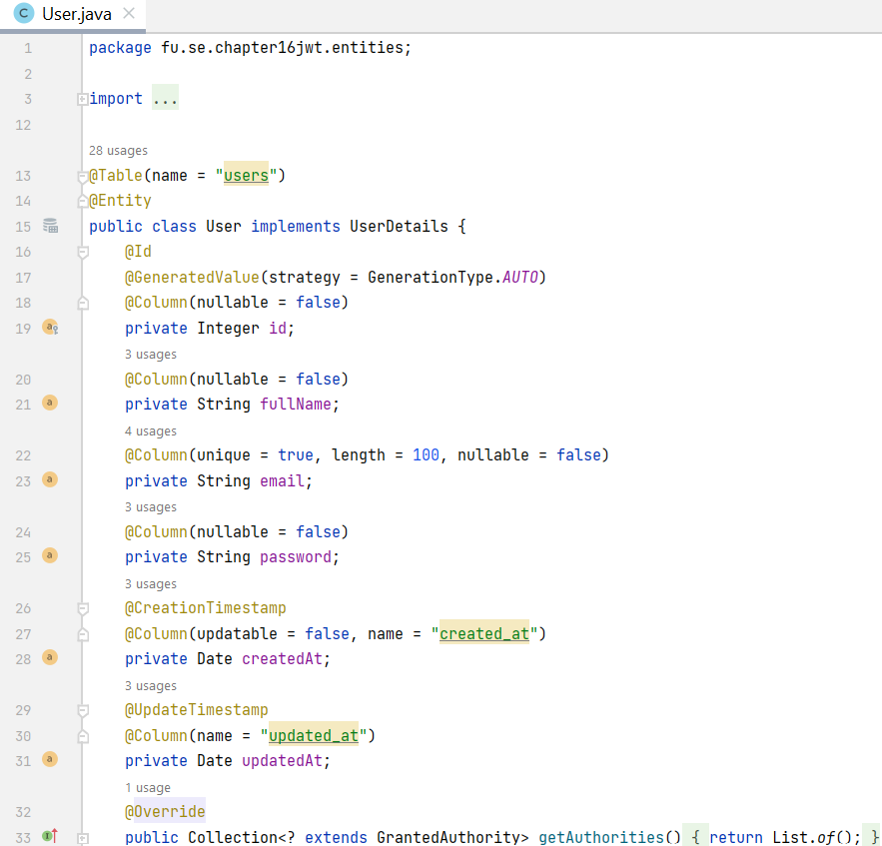
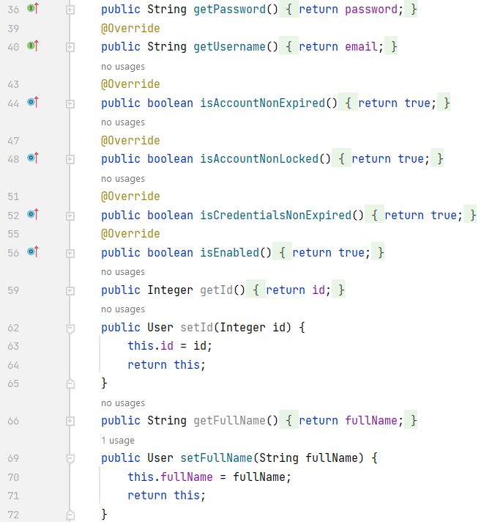

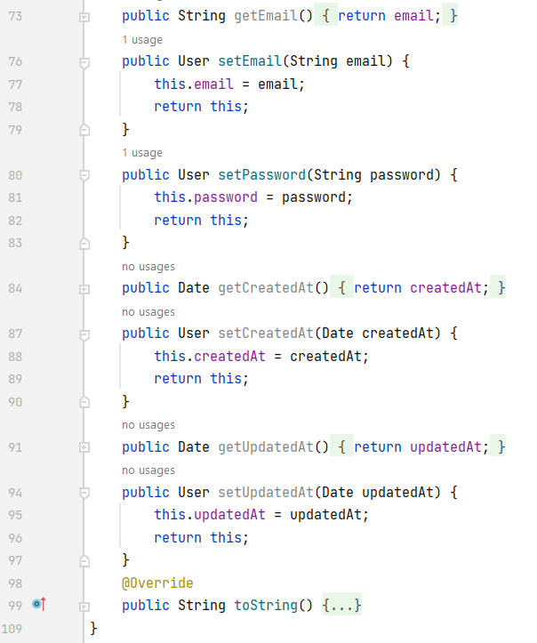

Step 02. Create a DTO and response data classes
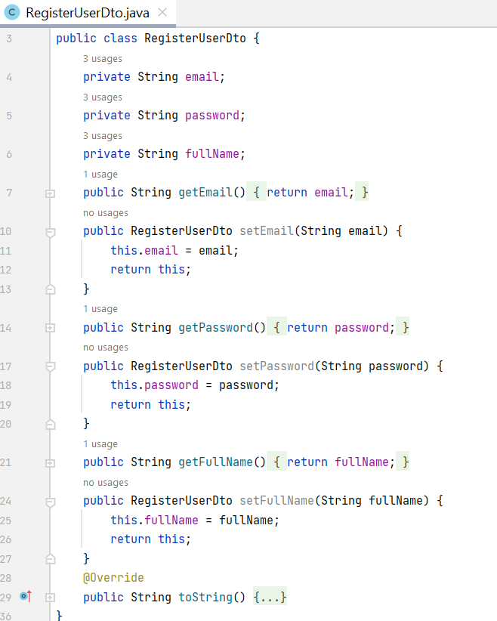
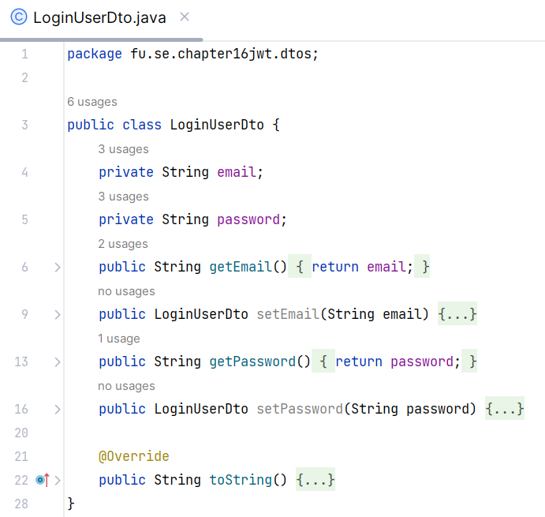

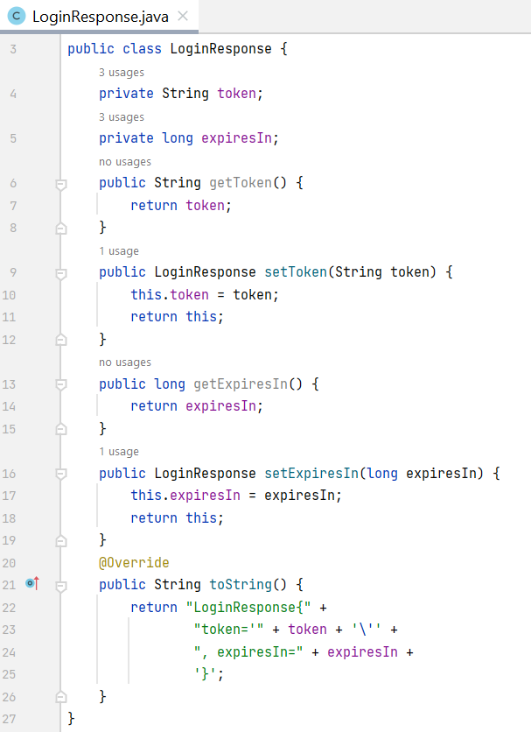
Step 03. Implement Repository by creating repositories package, UserRepository interface
- Create JPA repository interface, this interface extending CrudRepository
- Provides CRUD operations and more
- Just implement the findByEmail(String email) function
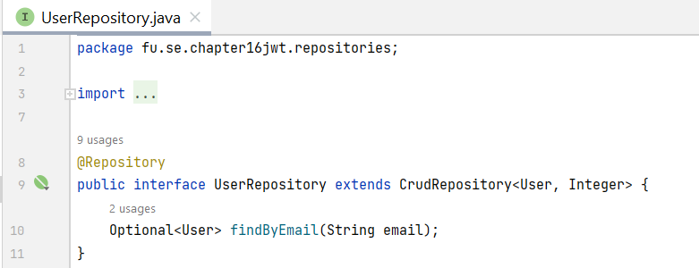

Step 04. Create related JWT classes
- Generate JWTs: Use io.jsonwebtoken.Jwts to create tokens with claims, expiration, and signing.
- Validate JWTs: Verify signature and extract claims.

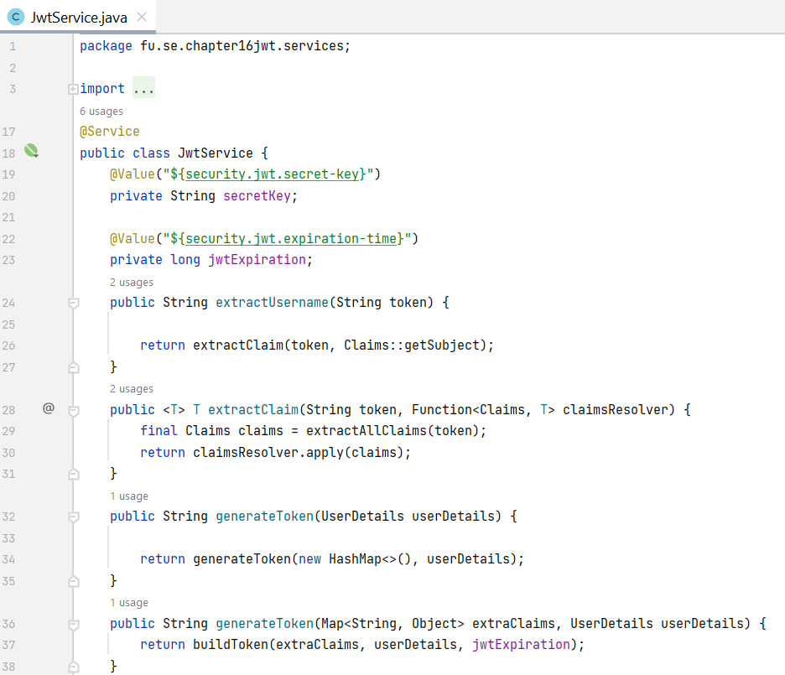

Override the security configuration
- userDetailsService() defines how to retrieve the user using the UserRepository that is injected.
- passwordEncoder() uses to encode the plain user password.
- authenticationProvider() sets the new strategy to perform the authentication.

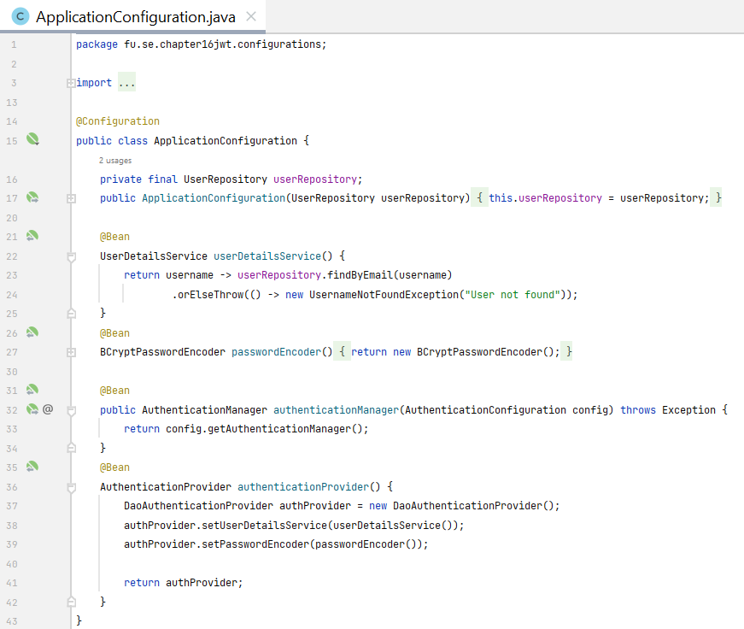

Step 05. Configure Spring Security

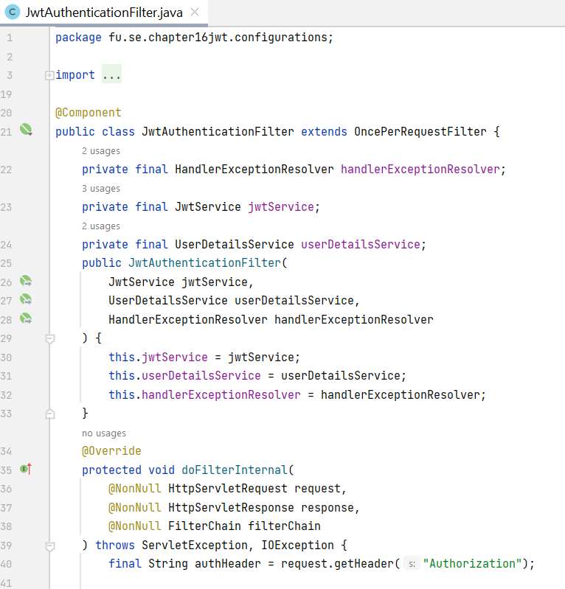
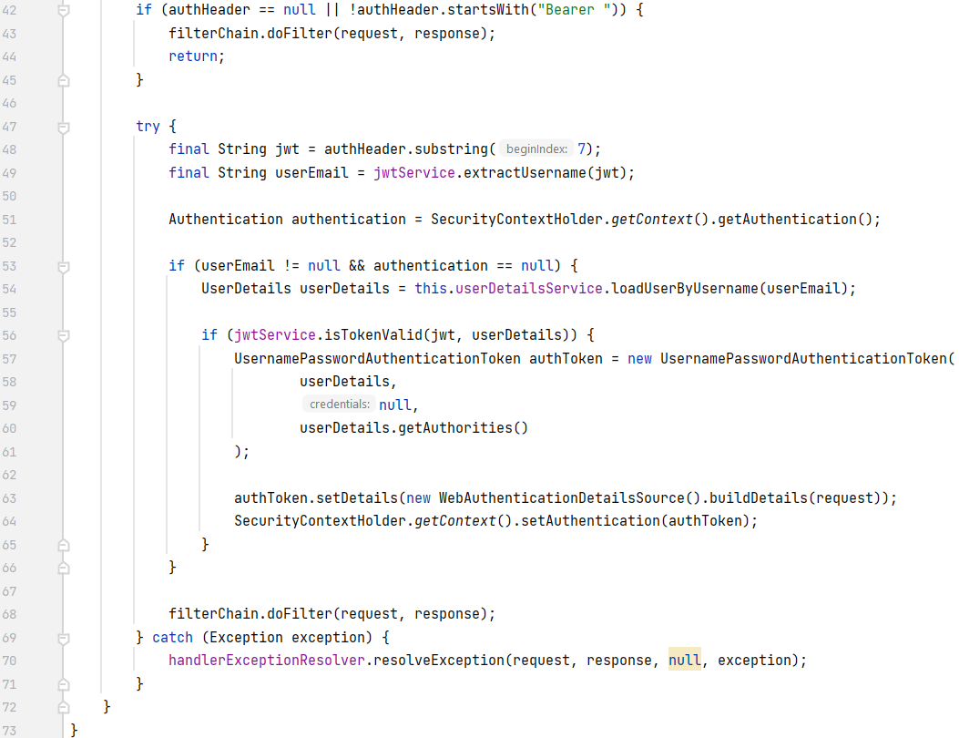

Configure the requester filter
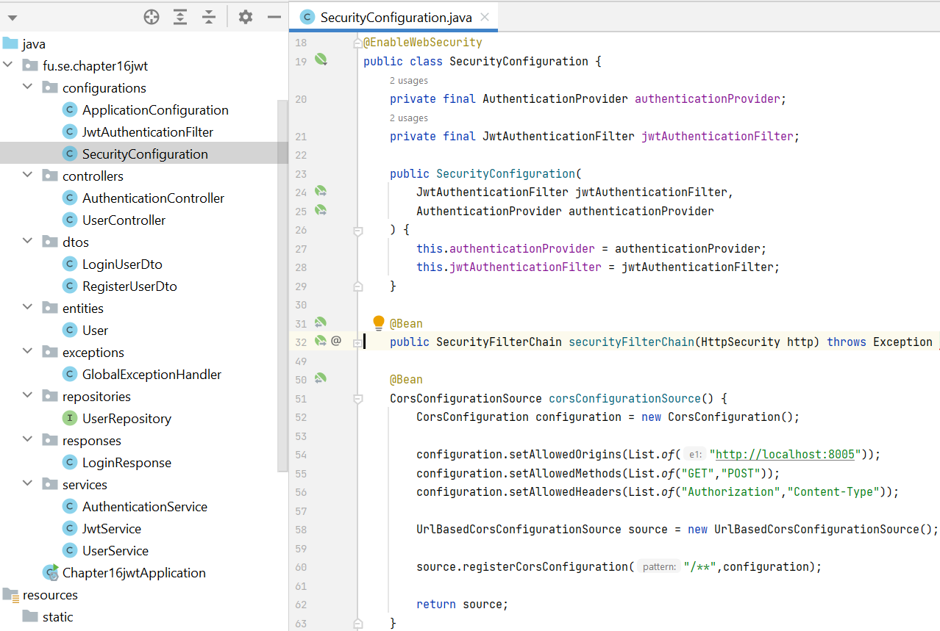

Create the authentication service
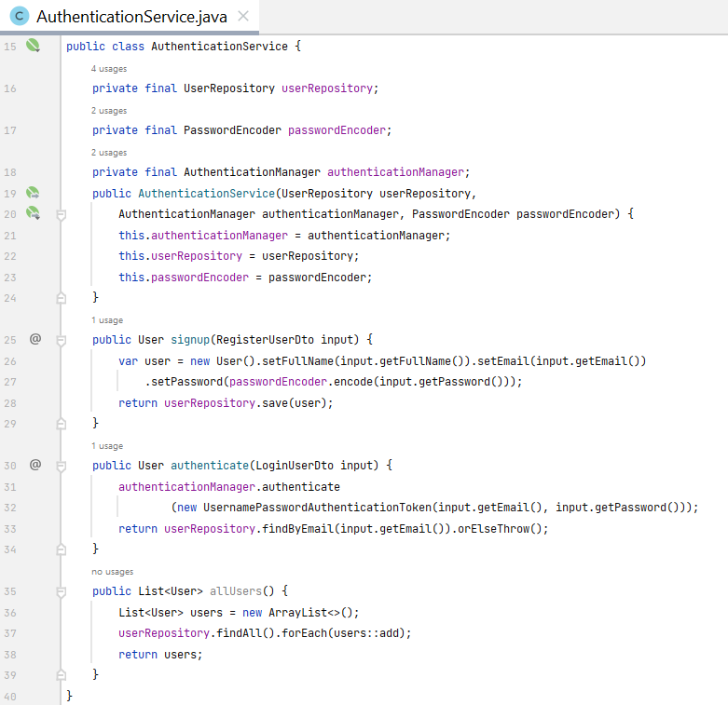

Step 06. Create an authentication controller
- Handle login requests.
- Authenticate the user.
- Generate JWT and send it in the response.

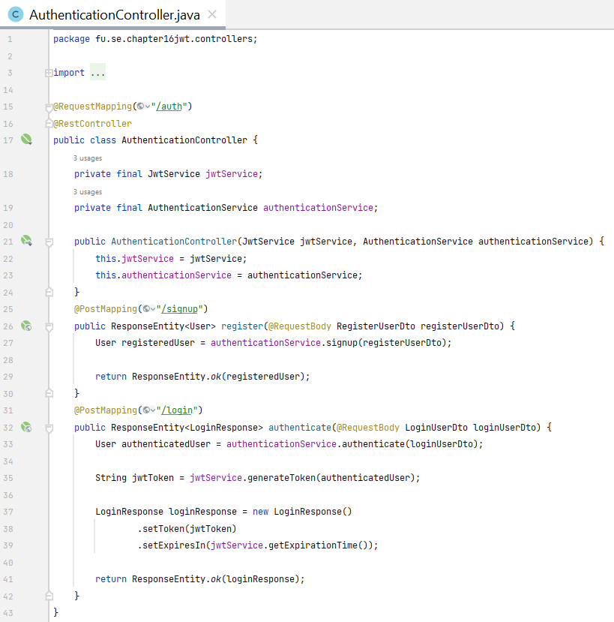
@RequestMapping - Maps HTTP requests to specific controller methods based on the request path, HTTP method, and other criteria. It can be used at both the class and method level. Attributes of @RequestMapping:
- value: Specifies the request path.
- method: Specifies the HTTP method (e.g., RequestMethod.GET, RequestMethod.POST).
- params: Specifies request parameters that must be present.
- headers: Specifies request headers that must be present.
- consumes: Specifies the content type of the request body.
- produces: Specifies the content type of the response body.

The annotations are shortcuts for @RequestMapping with specific HTTP methods. They simplify the code and improve readability.
- @GetMapping
- @PostMapping
- @PutMapping
- @DeleteMapping
- @PatchMapping
@PathVariable: Extracts values from URI path variables and binds them to method parameters.
@RequestParam - Extracts values from query parameters and binds them to method parameters.
@RequestParam attributes:
- value: Specifies the name of the query parameter.
- required: Indicates whether the parameter is required.
- defaultValue: Specifies a default value if the parameter is not present.

Step 07. Secure endpoints
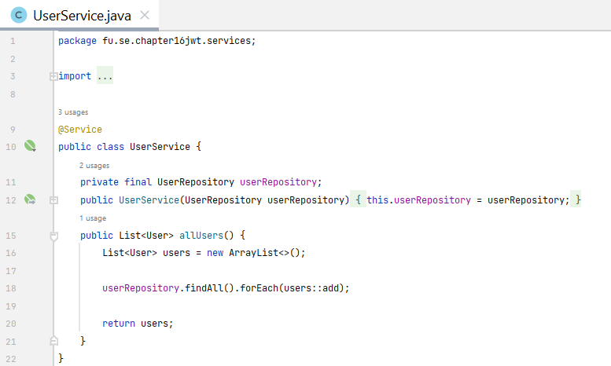
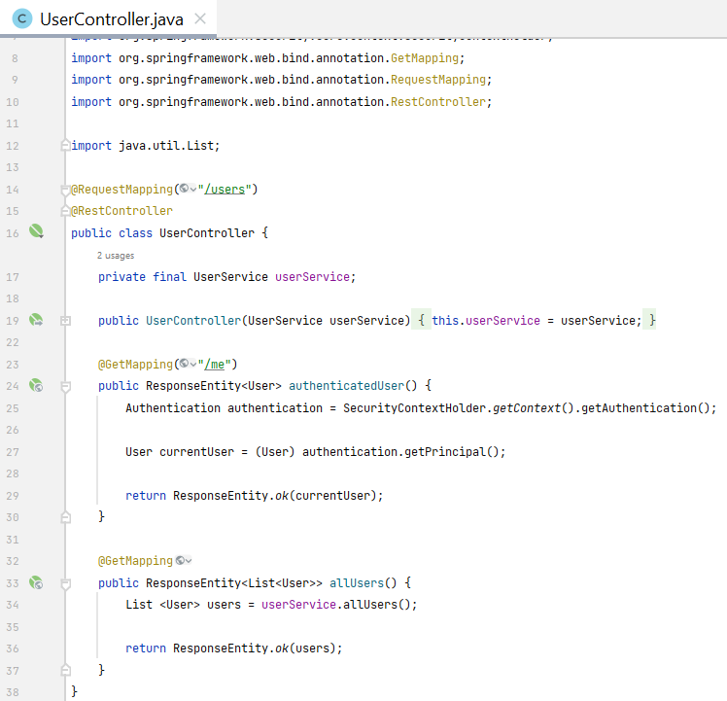

Step 08. Customize authentication error messages
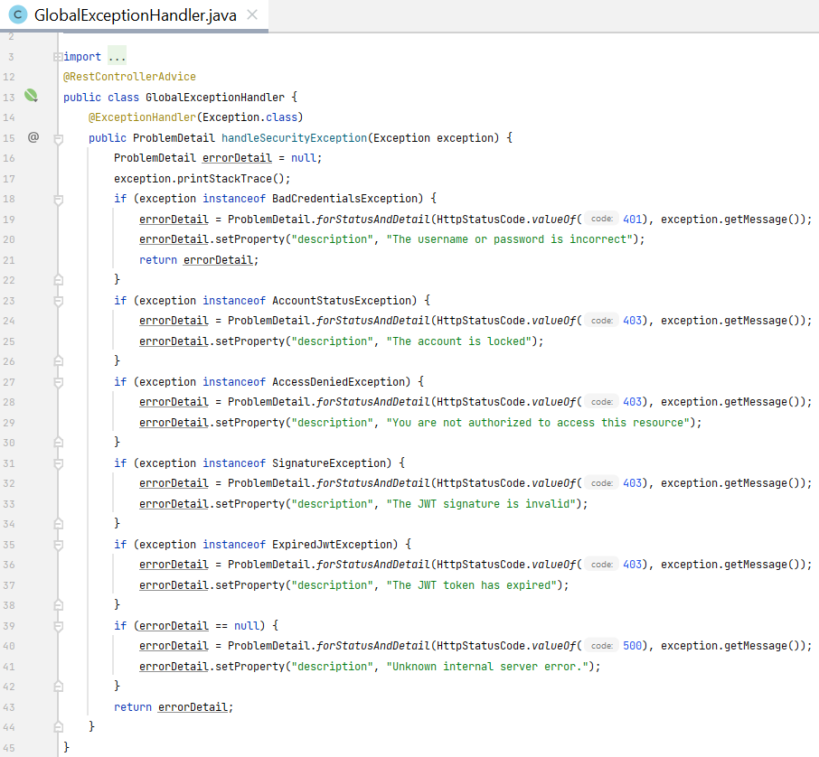

Activity 03: Run and test the RESTful API with JWT
Step 01. Run the RESTful API Project
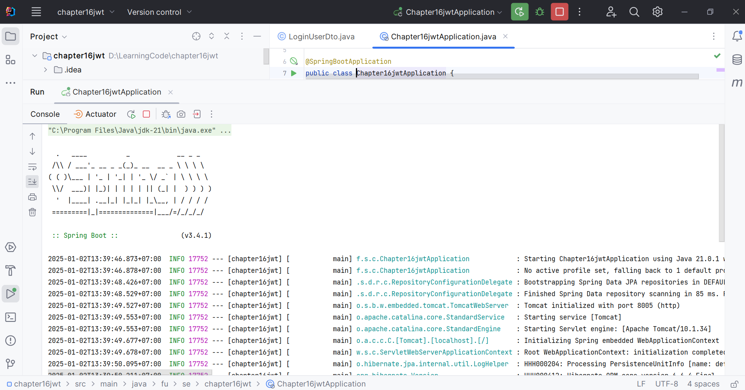

Step 02. Test the RESTful API using Postman

 | HTTP Method | Path
1 | POST | http://localhost:8005/auth/signup
2 | POST | http://localhost:8005/auth/login
3 | GET | http://localhost:8005/users/me
4 | GET | http://localhost:8005/users

Step 03. Test registration function using the POST method
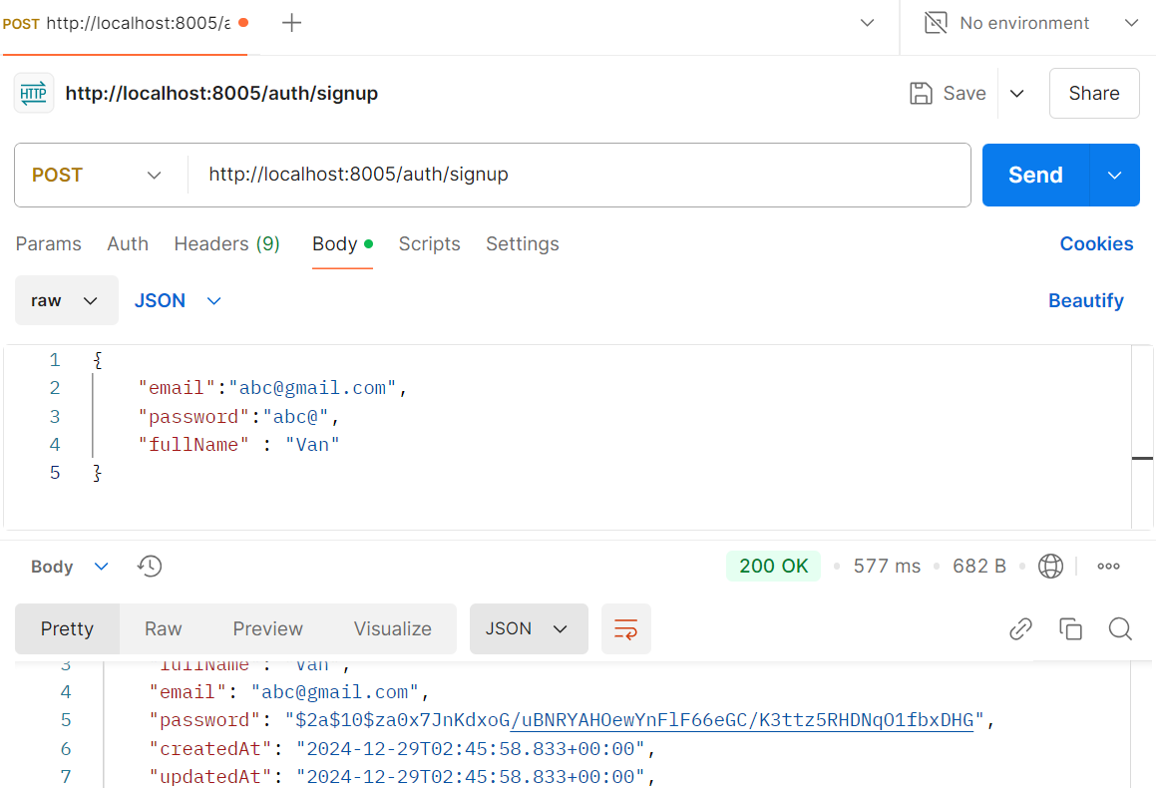

Step 03. Test login function using the POST method
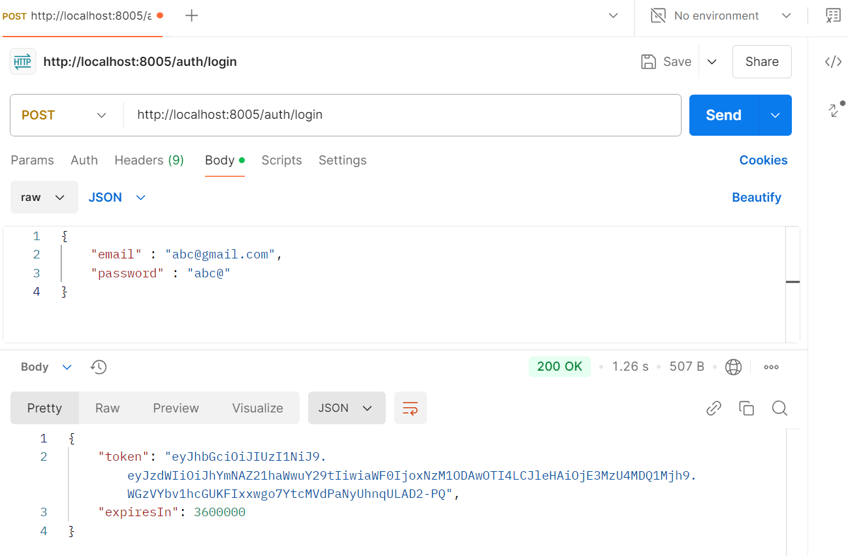

Step 04. Test user detail function using the GET method

